In HISTORIA NUMERUM By Barclay V. Head published by Oxford
University Press in 1887 on page 65, fig 42 I found interesting numeral
sign on old coin from 330 – 300 B.C.
The same number apears in VMS page 1 in 2nd and 3rd paragraph.
Bellow you will find the coin and the cipher designating number in VMS.

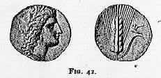


The reproduction of coin is not very clear but is the best way I could do.

John Stojko

